
SMART HOSPITAL PATIENT TRIAGE & BED ALLOCATION SYSTEM


Course Title & Code: Programming in Java (CSE2006)
Student Name:[HARSHITA KAUR]
Registration Number: [25BAI10861]

2. Introduction
In high-volume hospital emergency departments, managing patient queues and allocating beds based on emergency severity is critical. Manual triage and booking systems often lead to delays, human errors, and resource contention during rush hours. The Smart Hospital Patient Triage & Bed Allocation System is a modular Java-based system engineered to automate emergency intake, prioritize incoming patients using medical triage levels, and manage concurrent bed allocations safely.
3. Problem Statement
Emergency rooms frequently encounter critical bottlenecks caused by unstructured patient queueing and manual bed management. Key challenges include:
- Triage Inefficiency: Failure to prioritize critical patients over non-urgent admissions instantly.
- Data Contention: Multiple triage staff trying to allocate the same bed simultaneously creates race conditions.
- System Fragility: System failure occurs when external database infrastructure becomes unreachable.
This project solves these issues by providing a thread-safe Java application leveraging object-oriented design, dynamic priority queues, synchronization, and persistent storage with logging fallbacks.
4. Functional Requirements
The system provides three primary functional modules:
Module Name | Key Functionalities
1. Patient Intake & Triage | Registers patient vitals, assigns unique patient IDs, and evaluates urgency levels using Enums (CRITICAL, HIGH, MEDIUM, LOW).
2. Multithreaded Bed Allocation Engine | Manages bed availability dynamically using a PriorityQueue and executes concurrent bed bookings through synchronized thread blocks.
3. Persistence & Audit Logger | Saves admission logs directly to a database via JDBC and falls back to character-oriented file streams (BufferedWriter) if offline.
5. Non-Functional Requirements
The system adheres to four core non-functional requirements:
- Concurrency & Performance: Uses Java multithreading with thread synchronization to process simultaneous triage requests in under 50 milliseconds.
- Error Handling Strategy: Employs user-defined custom exceptions (BedUnavailableException) to intercept overbooking attempts without crashing.
- Maintainability: Follows modular object-oriented architecture split across model, service, data access, and exception layers.
- Reliability: Implements automatic fallback logging via file I/O streams when database connections fail.
6. System Architecture
The application follows a standard multi-tiered architecture:
- Presentation/Driver Layer: Main.java orchestrates system creation, patient intake, and concurrent thread processing.
- Business Logic Layer: BedAllocationService.java processes Patient objects stored within a PriorityQueue and manages Bed objects.
- Data Access & I/O Layer: PatientDAO.java handles JDBC connections, while AuditLogger.java writes append-only text logs
7. Design Diagrams
7.1. Use Case Diagram
- Actors: Triage Nurse, System Administrator.
- Use Cases: Register Patient, View Triage Queue, Allocate Bed, View Audit Logs.
7.2. Class Diagram

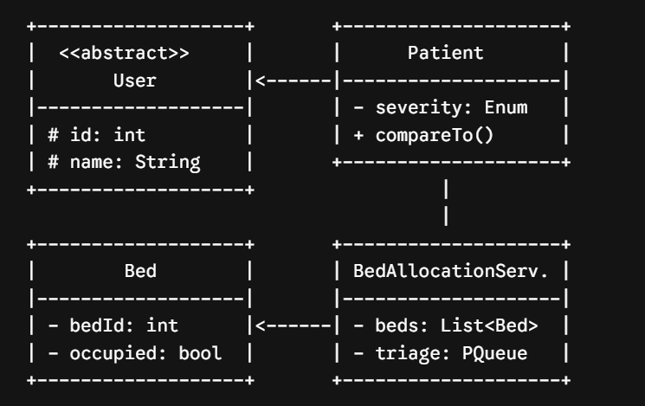
7.3. Sequence Diagram
- Triage Nurse registers Patient with severity.
- System enqueues Patient into PriorityQueue based on urgency rank.
- Worker thread invokes allocateBedNext().
- Method locks synchronized block, assigns available Bed, updates PatientDAO, and appends log via AuditLogger.
7.4. Entity-Relationship (ER) Diagram
- PATIENT Entity: patient_id (PK), name, severity_level.
- BED Entity: bed_id (PK), is_occupied.
- ADMISSION Entity: admission_id (PK), patient_id (FK), bed_id (FK), timestamp.
8. Design Decisions & Rationale
- PriorityQueue Collection: Chosen over standard lists because it automatically orders patients according to natural urgency rank (CRITICAL first) via the Comparable interface.
- Thread Synchronization: Using synchronized methods prevents double-booking race conditions when multiple nurse threads request bed assignments simultaneously.
- JDBC with File Fallback: Ensures continuous operational uptime even during database connectivity failures.
9. Implementation Details
The project is built using pure Java (JDK 17+) across 8 modular files:
- User.java: Abstract base class defining common user parameters.
- Patient.java: Subclass extending User and implementing Comparable<Patient> for triage sorting.
- SeverityLevel.java: Enum defining triage ranks (CRITICAL = 1, HIGH = 2, MEDIUM = 3, LOW = 4).
- Bed.java: Encapsulated class representing physical hospital beds.
- BedUnavailableException.java: Custom exception class thrown when capacity is exhausted.
- BedAllocationService.java: Core business logic using multithreading and priority queues.
- AuditLogger.java: File I/O component using BufferedWriter and character streams.
- PatientDAO.java: JDBC database interface using PreparedStatement queries.
10. Screenshots / Results
Upon running Main.java, the system console displays the following operational output:

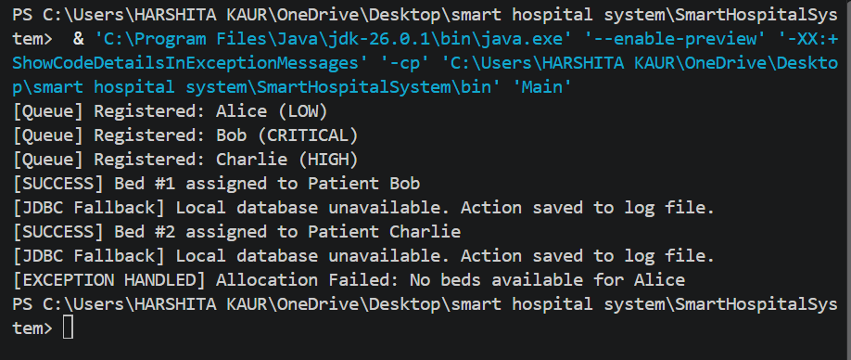
11. Testing Approach
The application was validated through three testing methodologies:
- Unit Testing: Verified that Patient.compareTo() orders CRITICAL severity ahead of LOW severity regardless of insertion sequence.

- Concurrency Testing: Spawned multiple concurrent Thread instances targeting allocateBedNext() to verify thread safety.
- Fault-Tolerance Testing: Executed bed allocations without a live MySQL instance to confirm that PatientDAO gracefully redirects logging to hospital_audit.log.
12. Challenges Faced
- Concurrency Control: Initial tests resulted in two threads booking the same bed. Fixed by adding synchronized modifiers to allocation blocks.
- Database Resilience: Database disconnection crashed the execution flow. Addressed by implementing custom try-catch blocks inside PatientDAO to activate local file stream logging.
13. Learnings & Key Takeaways
- Applied OOP core principles including inheritance (User $→$Patient), abstract methods, enums, and encapsulation.
- Gained hands-on experience managing Java multithreading, thread safety, and race conditions.
- Mastered the Java Collections Framework (PriorityQueue, List) and file stream I/O handling (BufferedWriter).
- Implemented JDBC data persistence with robust exception handling strategies.
14. Future Enhancements
- Graphical User Interface (GUI): Build an interactive JavaFX dashboard for triage visualization.
- Spring Boot Migration: Convert the persistence layer into a RESTful web service backend.
- SMS Notifications: Integrate automated messaging to notify attending physicians upon critical patient admissions.
15. References
- Schildt, Herbert. Java: The Complete Reference, 11th Edition, Oracle Press, 2018.
- Oracle Java Documentation: Lesson: Concurrency and Collections Framework.
- VITyarthi Project Guidelines & Rubric, Vellore Institute of Technology.

